LAB 6: CODE AND BRANCH COVERAGE ANALYSIS
Water Utility Billing System — Test Coverage Report

STUDENT NAME: | Tharunyah Sudhakar
SRN: | PES2UG24CS561
SECTION: | J
GITHUB REPOSITORY: | https://github.com/tharunyah/L6_L7_01_water_utility_billing

1. Objective & Software Requirements
● Understand the practical difference between code (line) coverage and branch coverage.
● Use coverage and pytest to measure, analyze, and achieve > 90% test coverage.
● Interpret coverage reports, identify edge cases, and design targeted test suites.
● Environment: Python 3.12, pytest 9.2.0, coverage 7.17.0.

2. Module Under Test (water_utility_billing.py)
The module under test implements water utility billing and meter security algorithms:
1. calculate_water_bill(accounts, base_fee): Computes bill amounts based on tiered usage blocks (<=50 @ $1.5, 50-100 @ $2.5, >100 @ $4.5 residential or $3.5 commercial), applies leak waivers (-$50 if bill > $200), flags irregular usage (<=0), and determines status (NORMAL, NO_ACTIVITY, EXCESSIVE_FLAGS).
2. check_meter_tampering(readings_matrix): Evaluates flow sensor delta readings to detect reverse flows. Flags TAMPER_SUSPECTED if backward flow count reaches 2 consecutive readings, returns CLEAR otherwise, or NO_DATA if empty.

3. Line Coverage vs. Branch Coverage
• Line Coverage measures whether each statement was executed at least once during test runs. While useful, line coverage can report 100% even when conditional branches (e.g. false paths of if-statements) are never tested.
• Branch Coverage measures whether every branch in control structures (if/else, loops) evaluates to both True and False. Branch coverage guarantees that alternate logic, exceptions, and boundary edges are thoroughly validated.

4. Initial Coverage Baseline
Running the initial starter test (test_water_utility.py):
• Initial Line Coverage: 46% (25 missing lines)
• Initial Branch Coverage: 41% (8 partial branches, 25 missed statements)

5. Task 1: Code Coverage Analysis (>90%)
A comprehensive test suite CodeCoverageTest_water_utility_billing.py containing 17 test cases was developed. It addresses every statement across calculate_water_bill and check_meter_tampering.
Result Achieved: 100% Line Coverage (46/46 statements covered, 0 missed).
Water Billing Output Screenshot (Code Coverage):
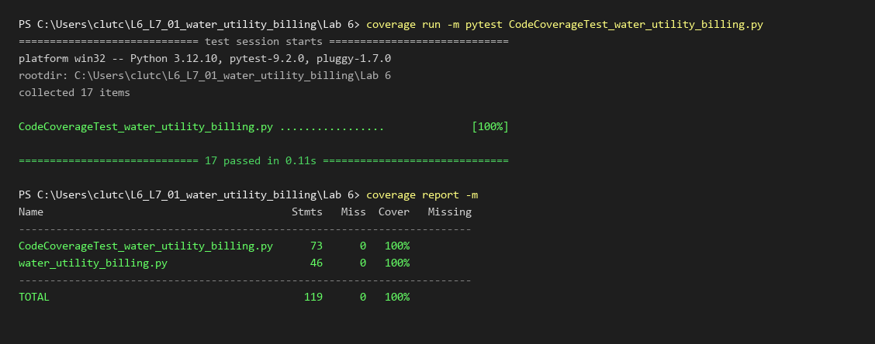

6. Task 2: Branch Coverage Analysis (>90%)
A targeted test suite BranchCoverageTest_water_utility_billing.py containing 19 test cases was developed. It evaluates both outcomes of all 34 decision branches in the module, including type validation, tier transitions, break conditions, leak waiver eligibility thresholds, flag count thresholds, and backflow counter reset logic.
Result Achieved: 100% Branch Coverage (34/34 branches covered, 0 partial, 0 missed).
Water Billing Output Screenshot (Branch Coverage):
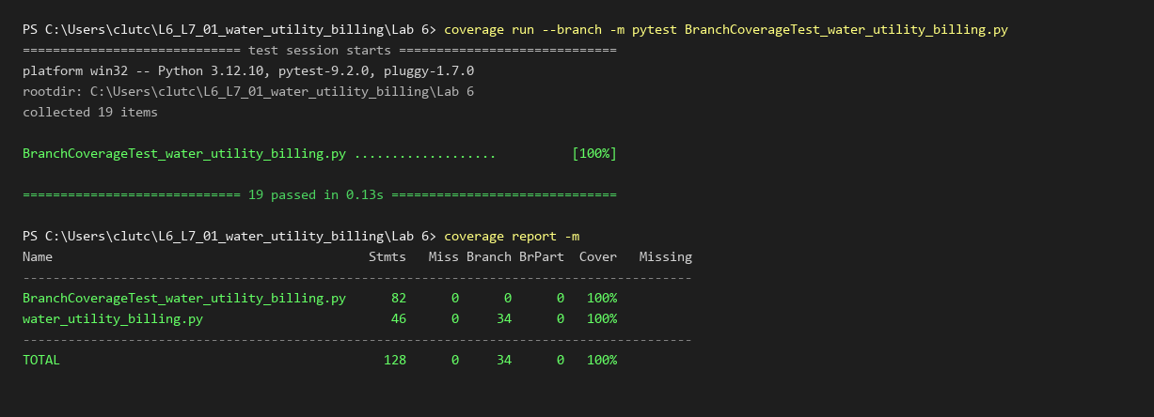

7. Deliverables & Commit Summary
Commit | Commit Message | Deliverables
Commit 1 | water billing code coverage test cases and output screenshot | CodeCoverageTest_water_utility_billing.py, code_coverage_screenshot.png (100% Line Coverage)
Commit 2 | water billing branch coverage test cases and output screenshot | BranchCoverageTest_water_utility_billing.py, branch_coverage_screenshot.png, Lab6_Report_PES2UG24CS561.docx (100% Branch Coverage)

8. Conclusion
Both code coverage and branch coverage achieved 100%, exceeding the required 90% threshold. All edge cases, conditional branches, and validation errors were completely verified.

